MAE 4300 Design Project

Introduction

The purpose of this design report is to analyze the output shaft of a gear box. The system was geared such that 720.29 in*lbf torque would result in 14586 in*lbf output torque. To do so, it required four gears and three shafts. The objective of this report was to analyze the last of the three shafts and determine proper tolerances such that the safety factor of each part would be exceed 1.5.

There are many obstacles to over come when developing a reliable output shaft. First the internal forces were found by determining the resulting forces acting on the shaft. Bearing must be fitted to the shaft that can withstand the Statics bearing force, from that a diameter can be determined from each point on the shaft I through R.

Output Shaft Design

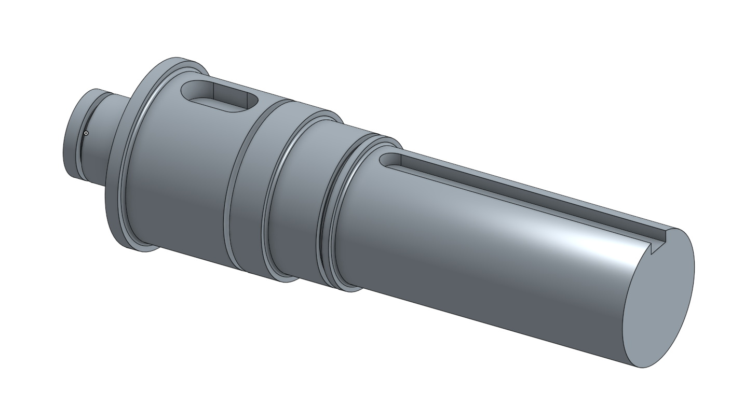

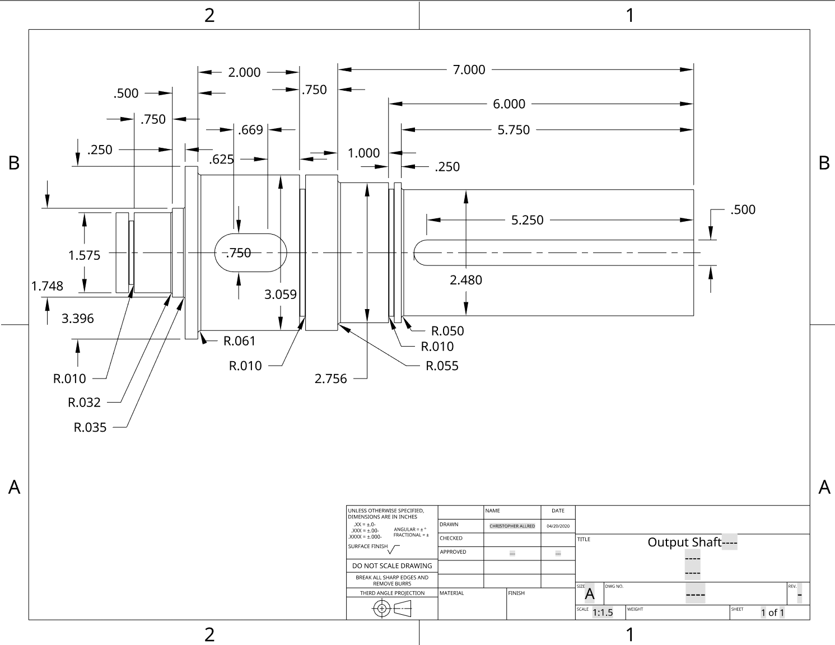

**Figure 1, A sketch of the shaft labeling analysis points**

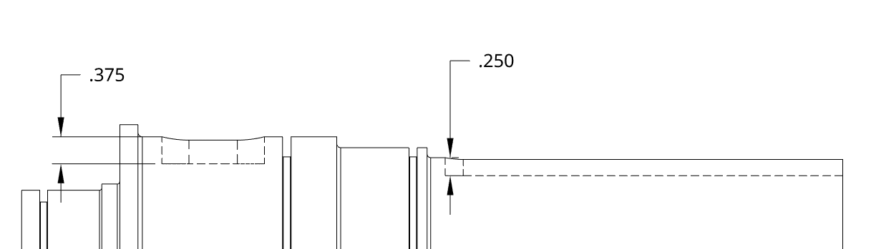

L

I J K M N O P Q R

**Table 1: material properties, moment, and torque at analysis points on the shaft**

|  |  |  |
| --- | --- | --- |
|  | Moment (in* lbf) | Torque (in*lbf) |
| I | 539.11 | 0 |
| J | 898.5243 | 0 |
| K | 1257.9341 | 0 |
| G | 2695.573 | 14586 |
| L | 1838.001 | 14586 |
| M | 1553.93 | 14586 |
| N | 1131.8152 | 14586 |
| O | 721.9903 | 14586 |
| P | 200 | 14586 |
| Q | 150 | 14586 |
| R | 100 | 14586 |

**Table 2 Stating Selected Diameters**

|  |  |  |  |  |  |  |
| --- | --- | --- | --- | --- | --- | --- |
| Selected Diameters (in) | | | | | | |
| D1 | D2 | D3 | D4 | D5 | D6 | D7 |
| 1.5748 | 1.748 | 3.3955 | 3.059 | 3.059 | 2.7559 | 2.48 |

**Table 2: Listing all the safety factors at points on the shaft**

|  |  |  |
| --- | --- | --- |
| Safety Factors | Against Fatigue | Against Yielding |
| I | 7.8 | 11.162 |
| J | 8.32 | 12.04 |
| K | 28.8 | 45.21 |
| L | 19.71 | 30.942 |
| M | 2.18 | 3.04 |
| N | 7.03 | 4.519 |
| O | 4.24 | 2.597 |
| P | 3.24 | 1.866 |
| Q | 6.32 | 3.569 |
| R | 6.4 | 3.584 |

**Table 3: computed bearing reaction forces, C10 loads, and bearing type**

|  |  |  |  |
| --- | --- | --- | --- |
|  | Reaction Forces (lbf) | C10a (lbf) | Bearing Type: |
| A | 1437.639 | 7822.5859 | Cylindrical Roller Bearing |
| B | 1112.5678 | 6053.7848 | Cylindrical Roller Bearing |

**Table 4: Gear, Shaft key material, and dimensions**

|  |  |  |  |  |  |  |
| --- | --- | --- | --- | --- | --- | --- |
| Feature | Material Name | Yield Strength (ksi) | Hight (in) | Width (in) | Length (in) | Death (in) |
| Key 1 | 1020 CD | 57 | ¾ | ¾ | 0.6692 | 3/8 |
| Key 2 | 1015 HR | 27.5 | 5/8 | 5/8 | 2.0806 | 5/16 |
| Gear | Not required by | contracted rubric | *** | *** | *** | *** |

Calculations

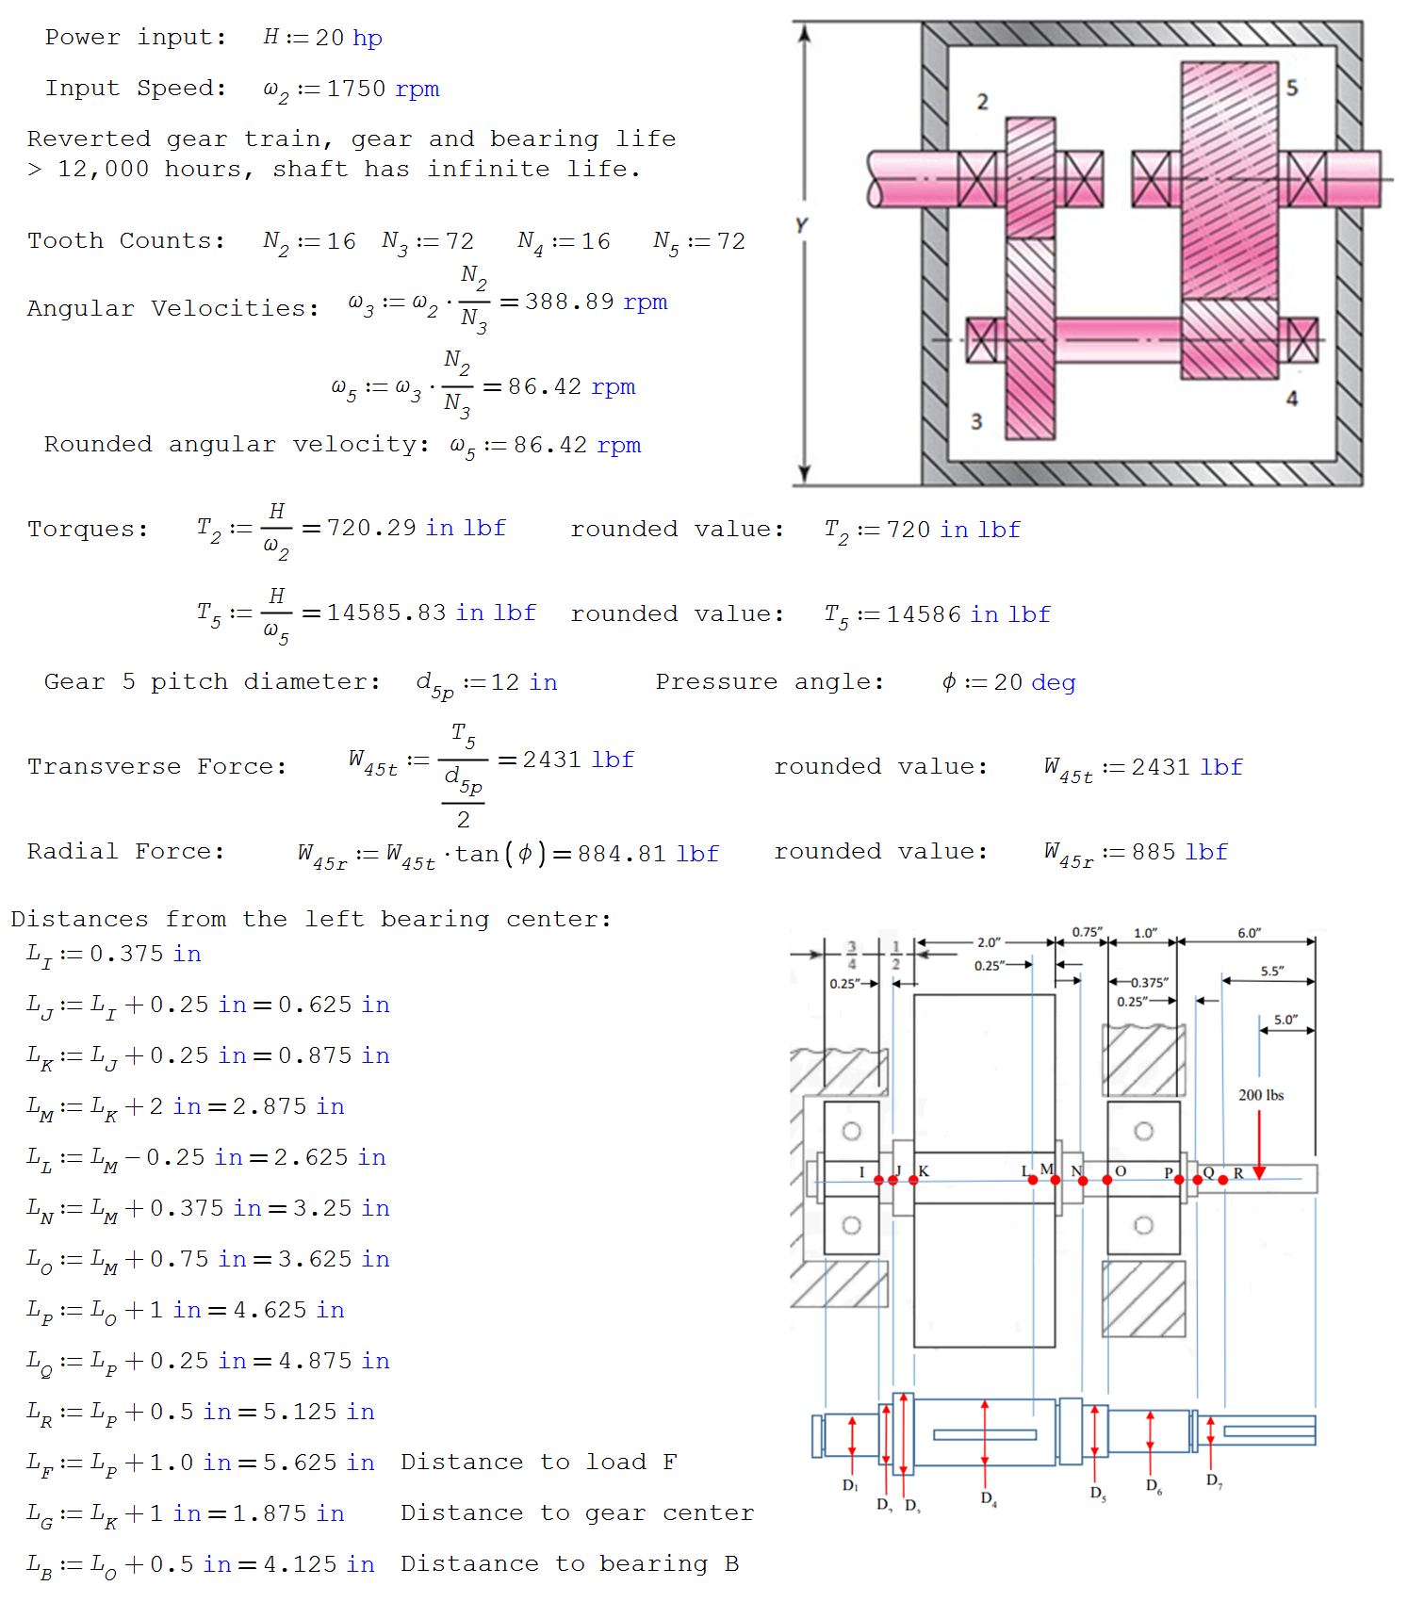

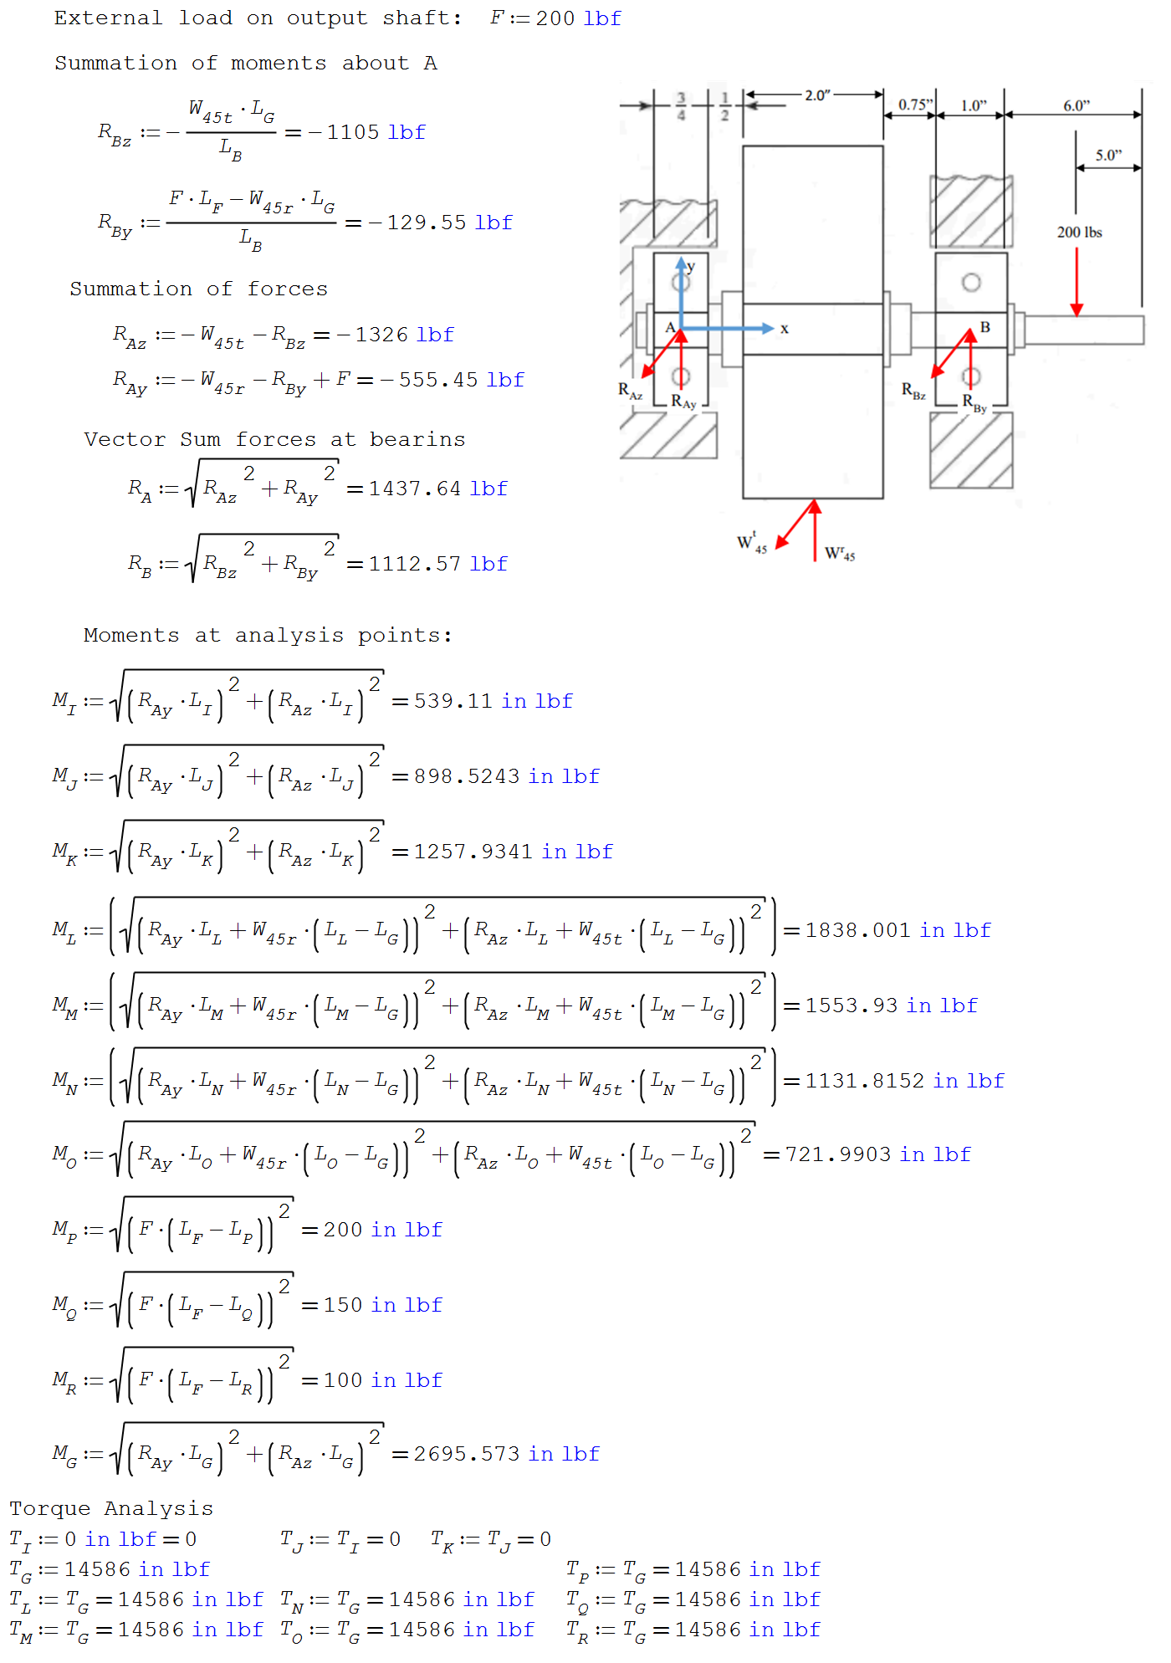

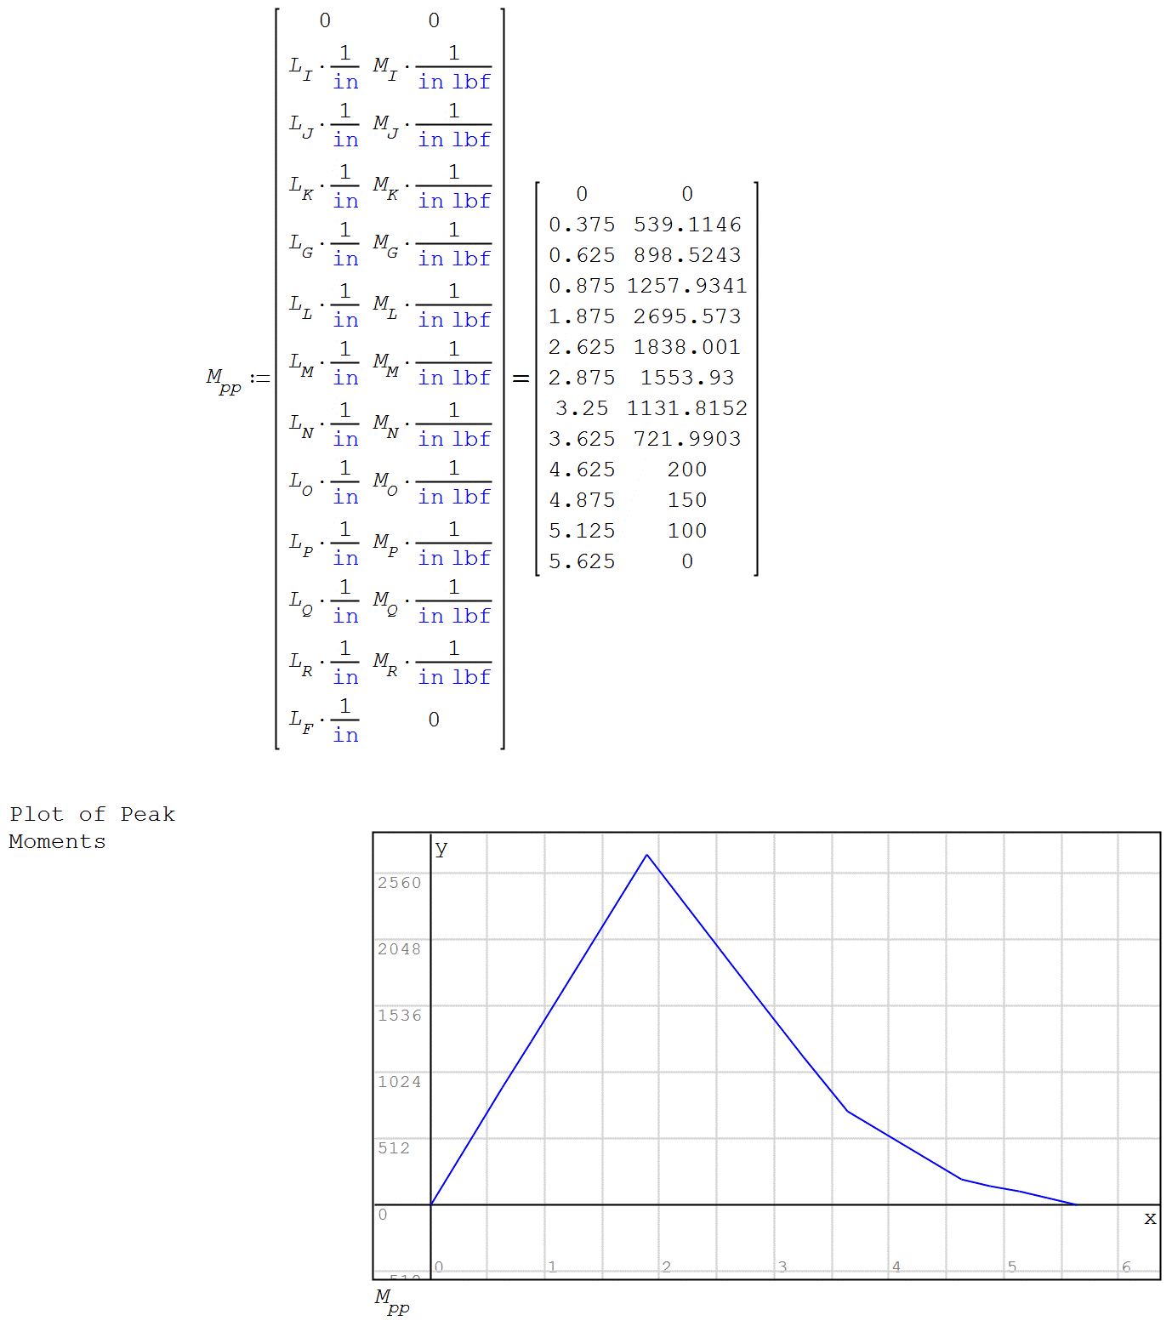

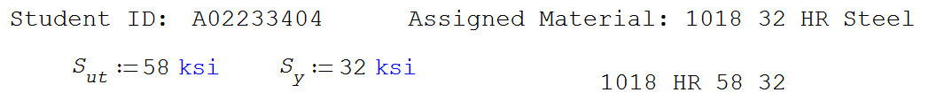

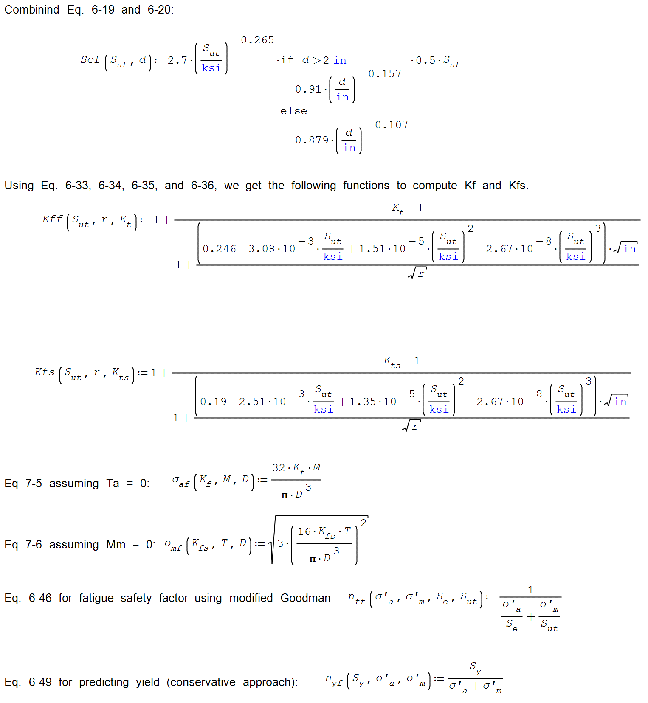



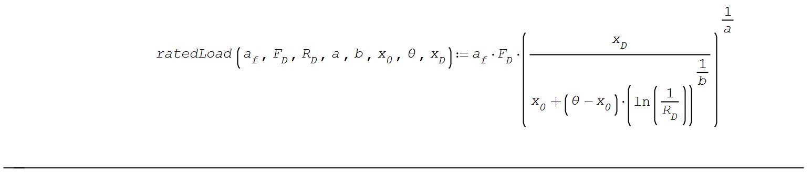

Point Calculations

The diameter for bearing 1 at D1 is 1.5748 in

The diameter for bearing 2 at D6 is 2.7559 in

The rest of the bearings are calculated by guess and check

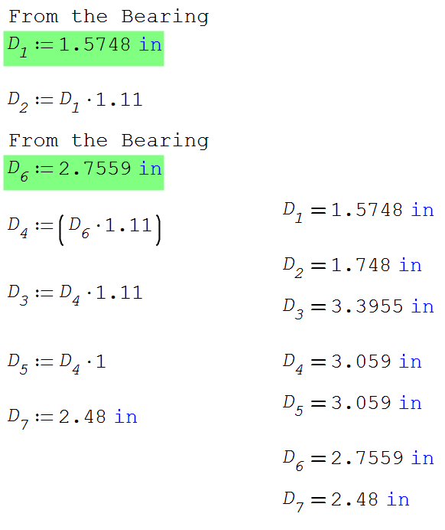

This is the Logic code to help:

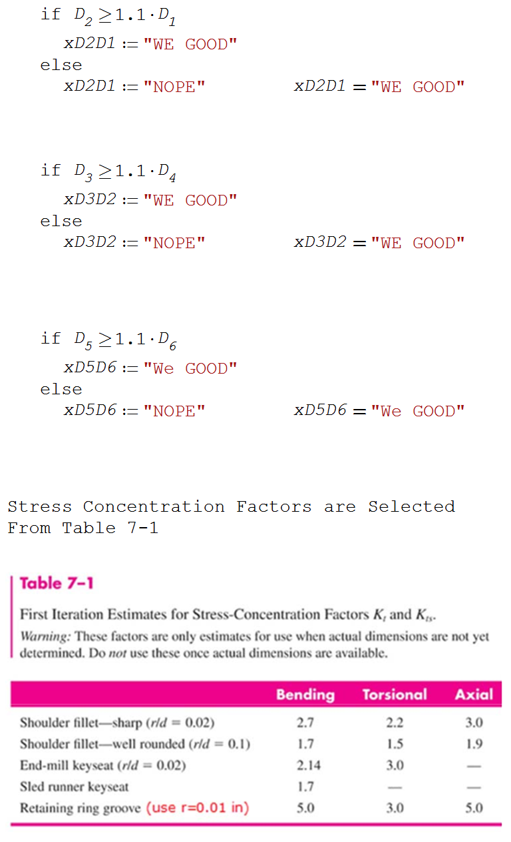

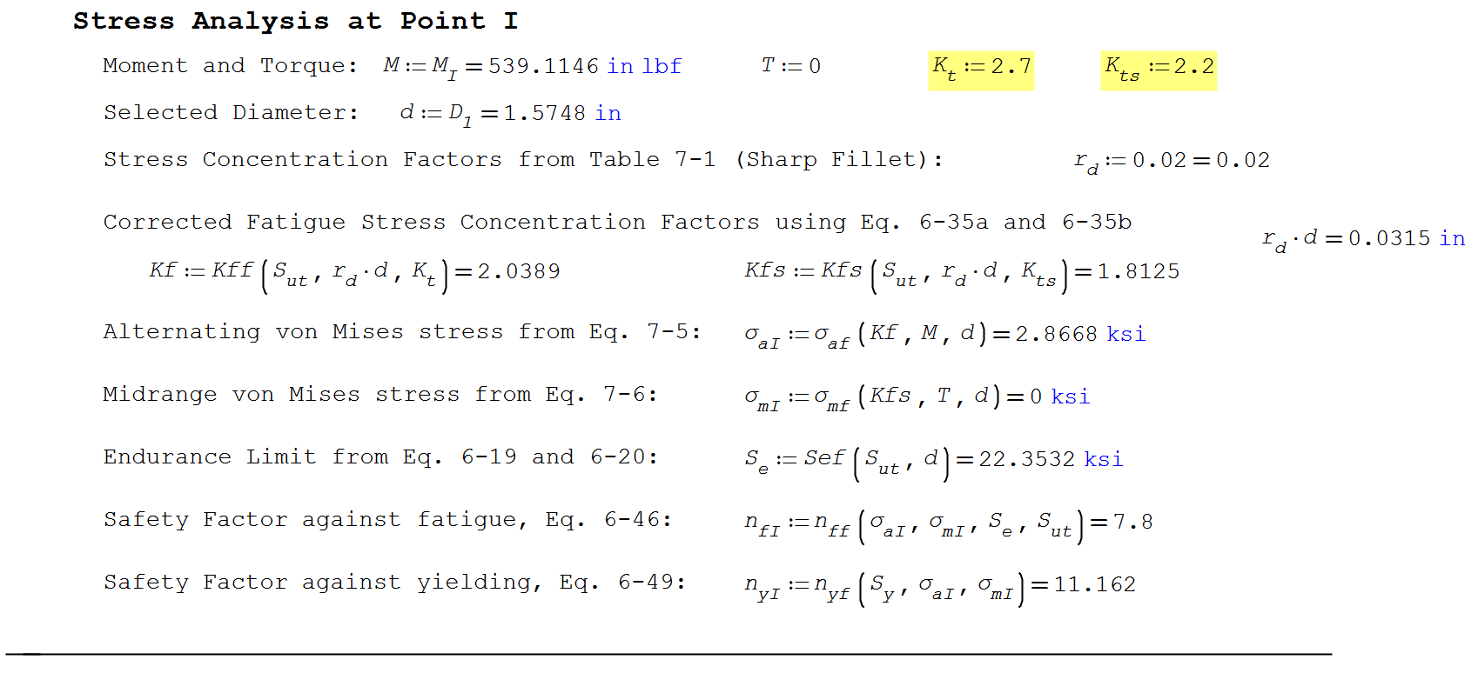

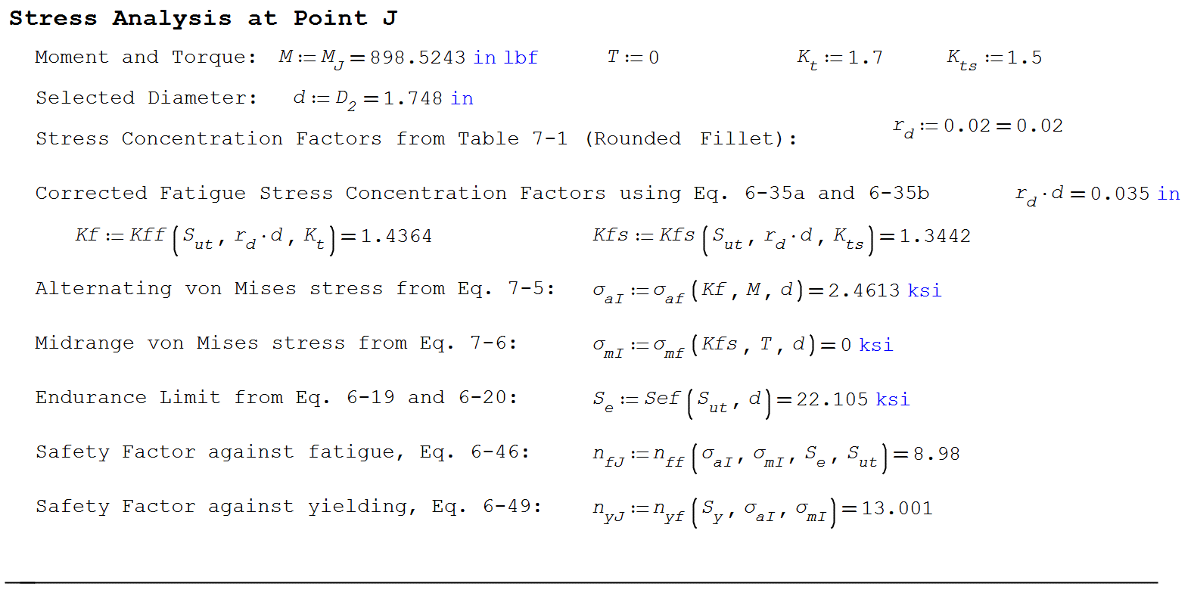 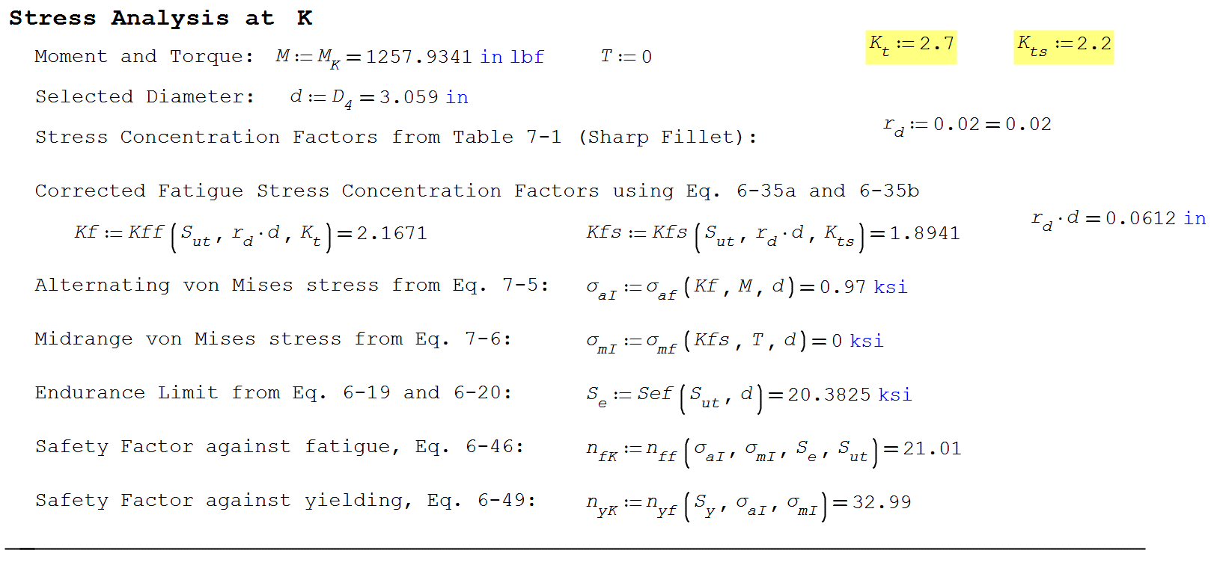 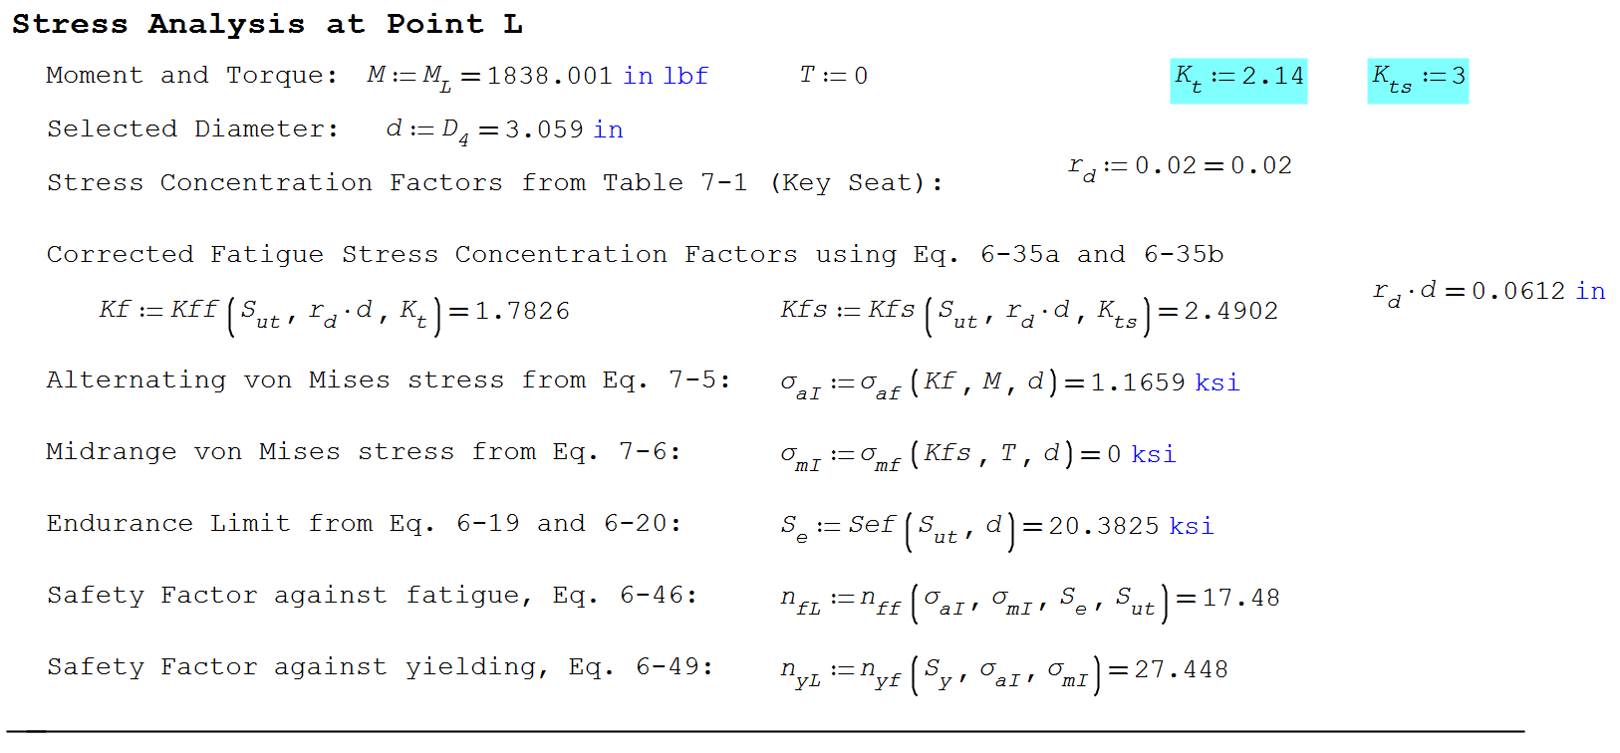 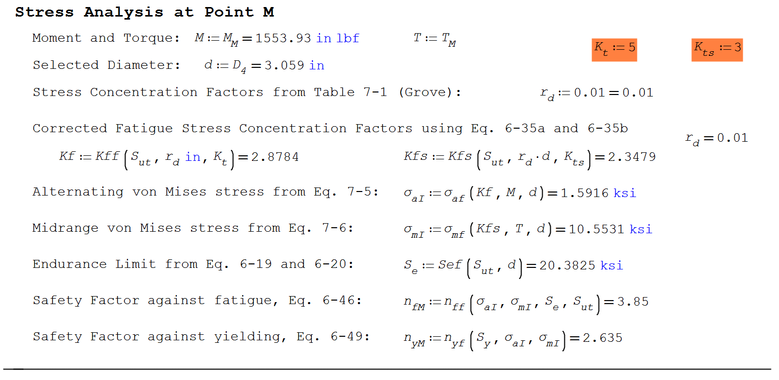 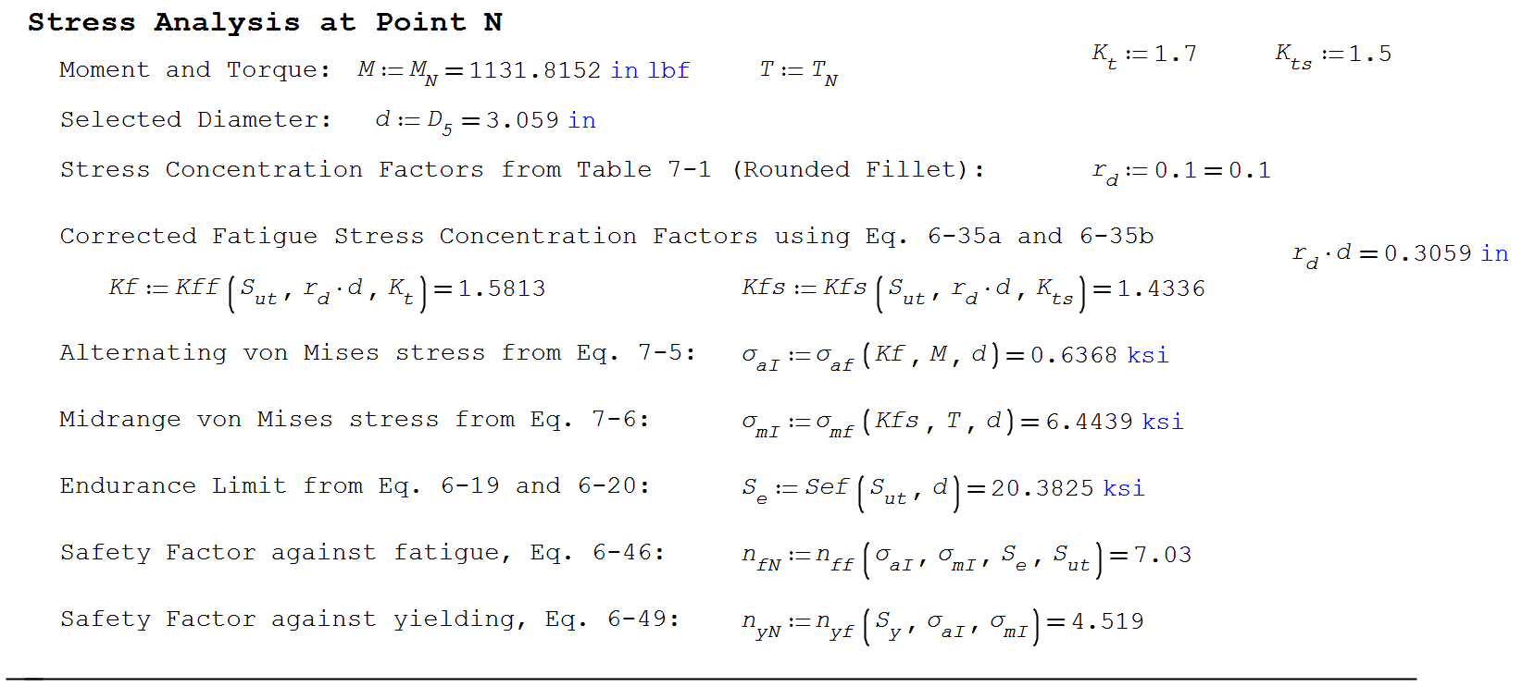 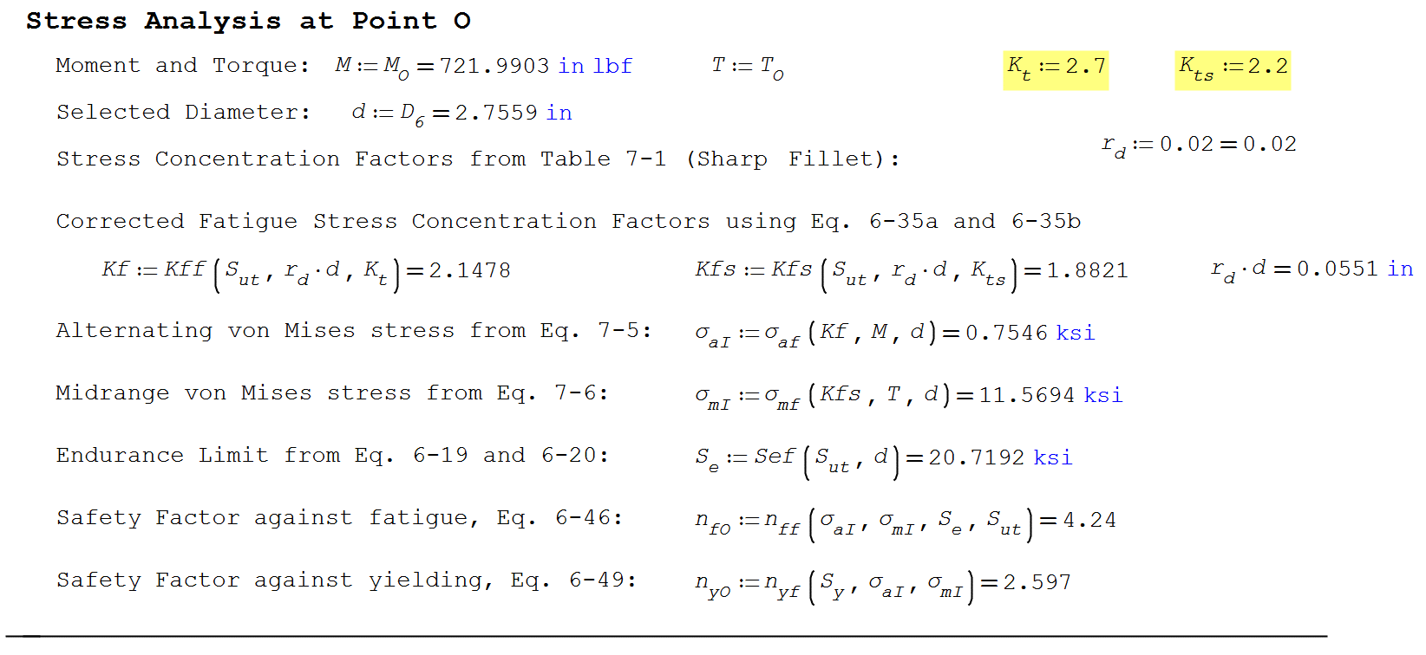 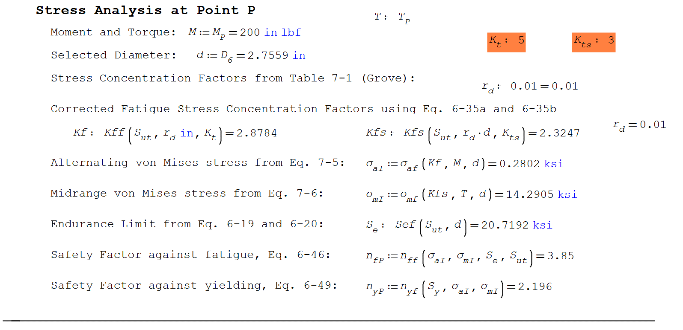 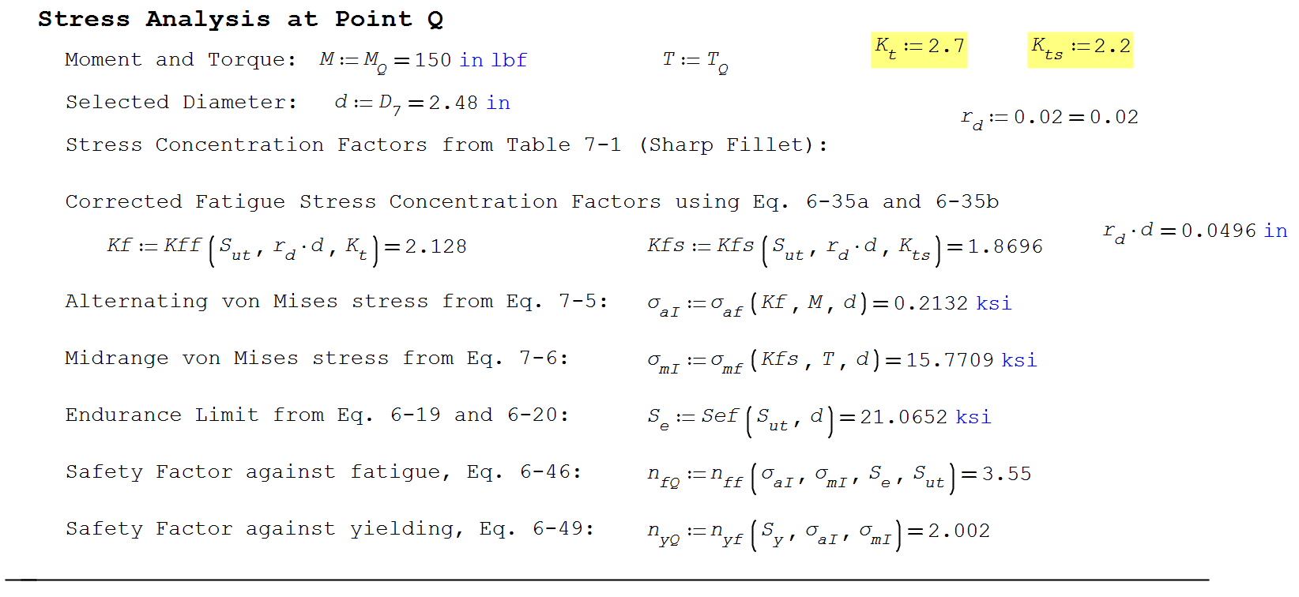 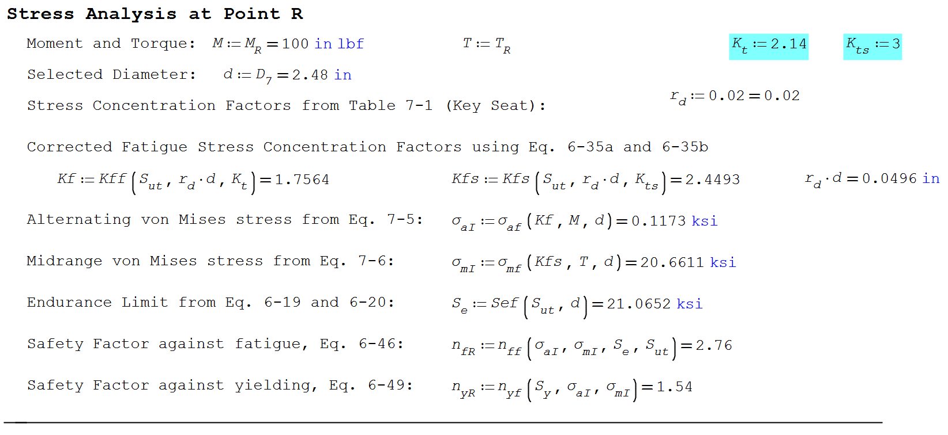

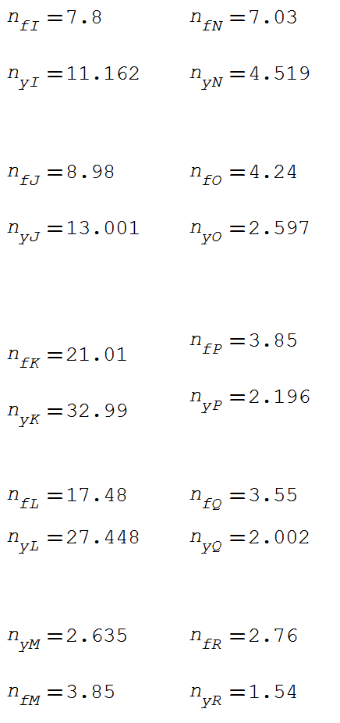 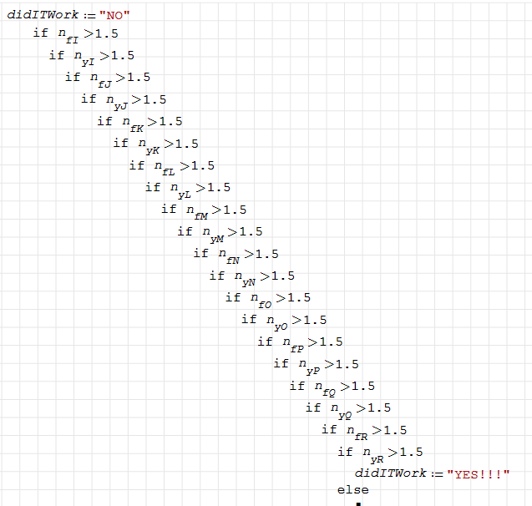



Bearing Calculations

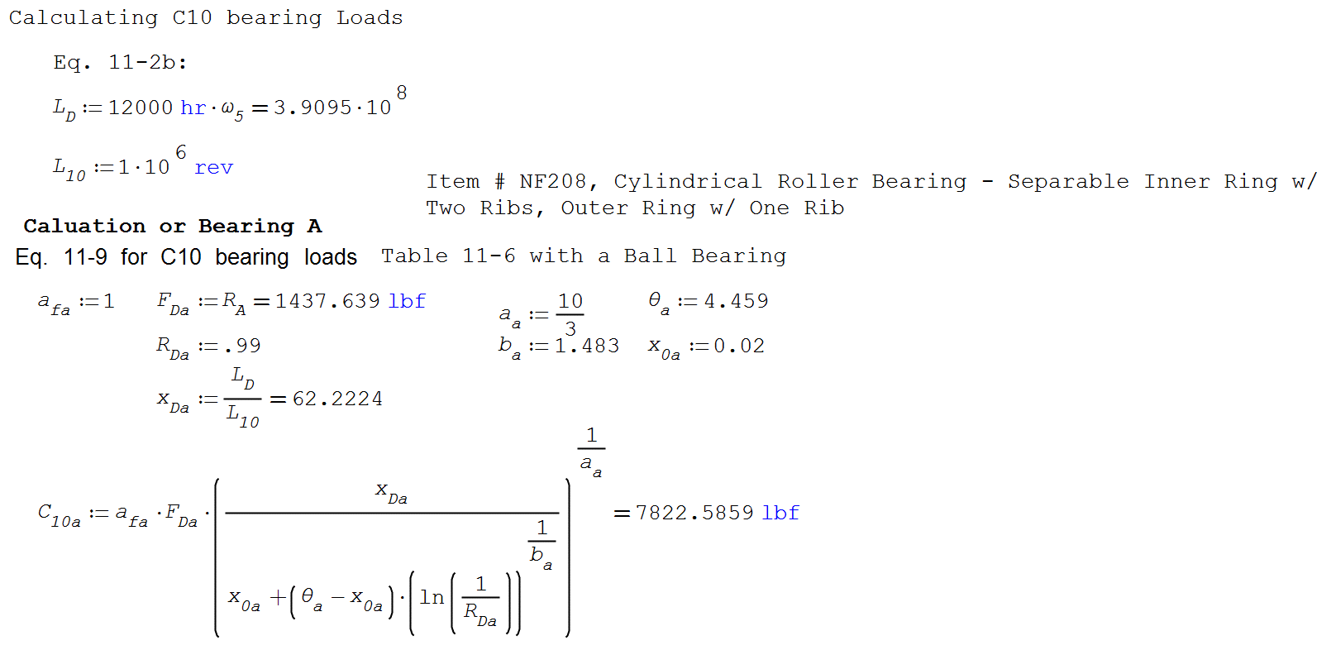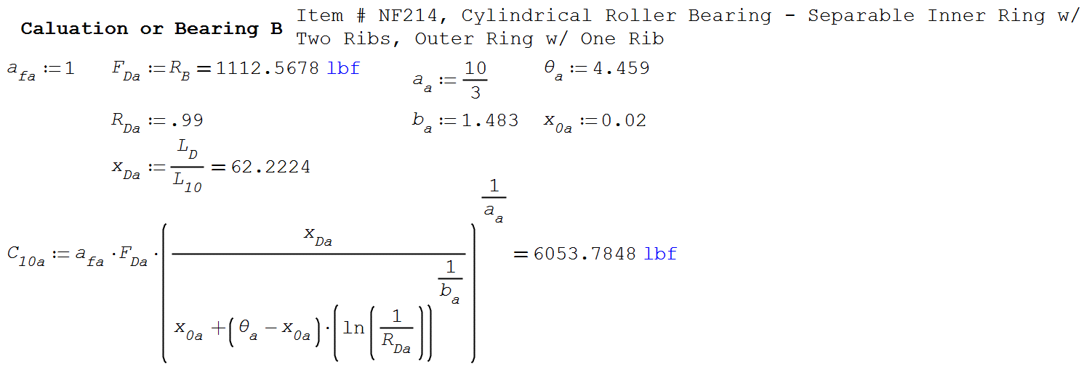

Key Length Calculations

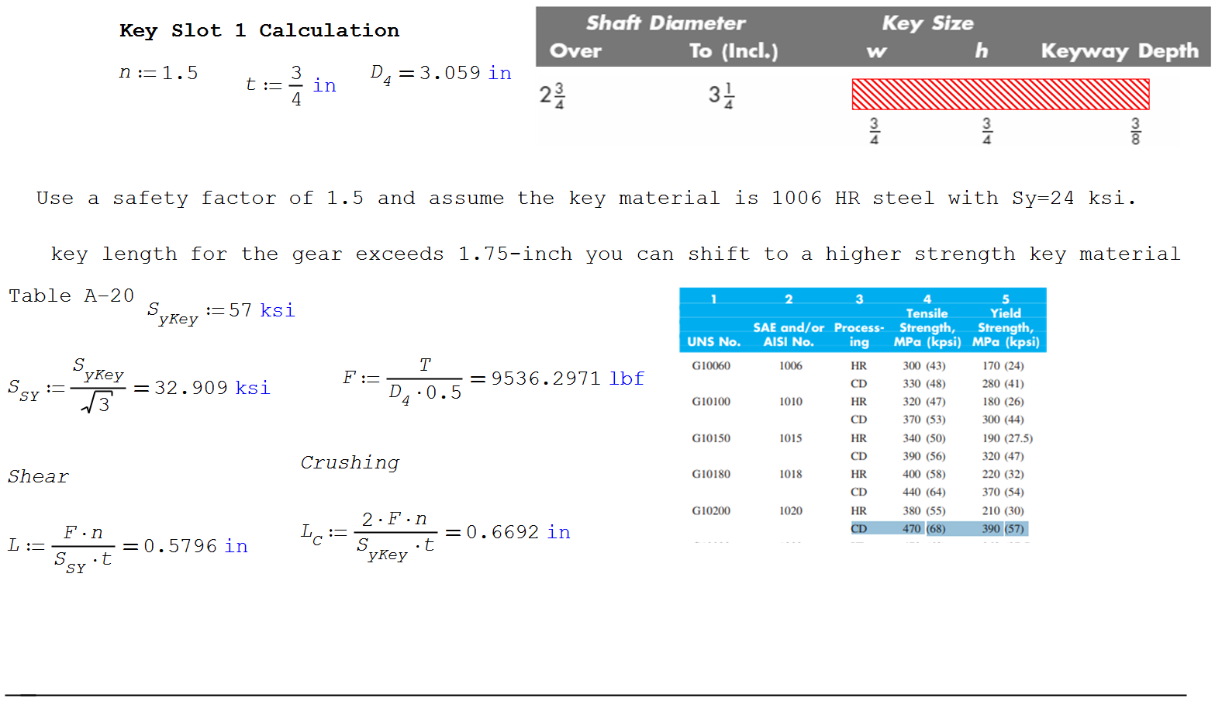

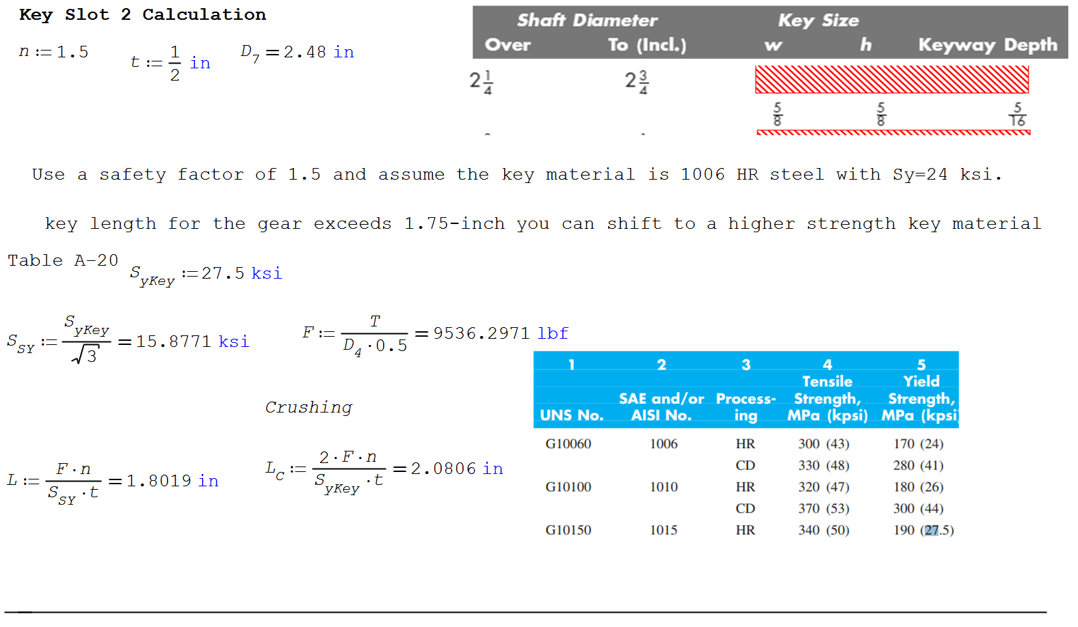

Appendix

Selected bearings

Bearing One for D1

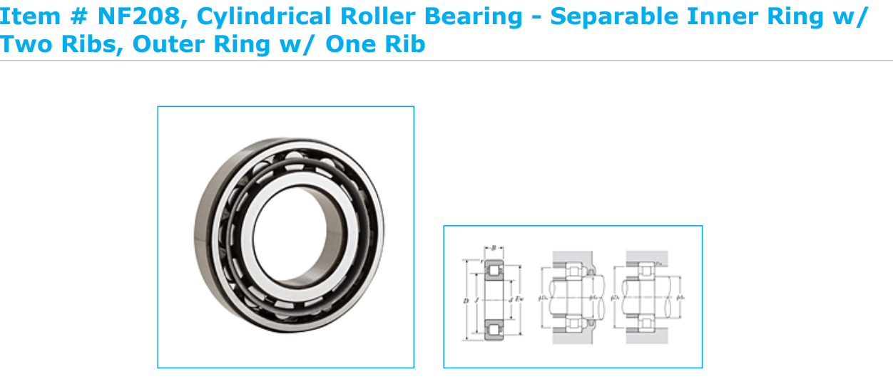

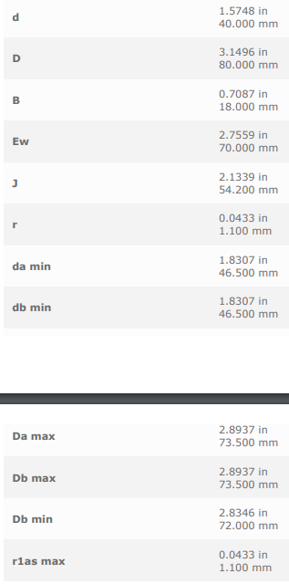 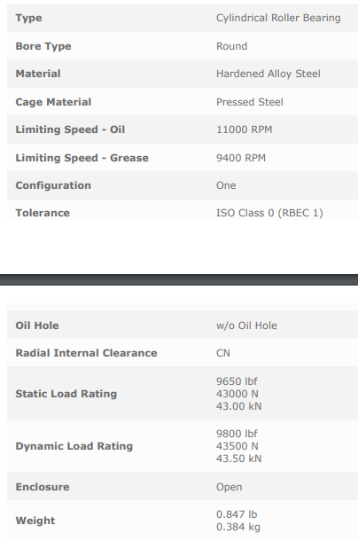

Bearing Two for D6

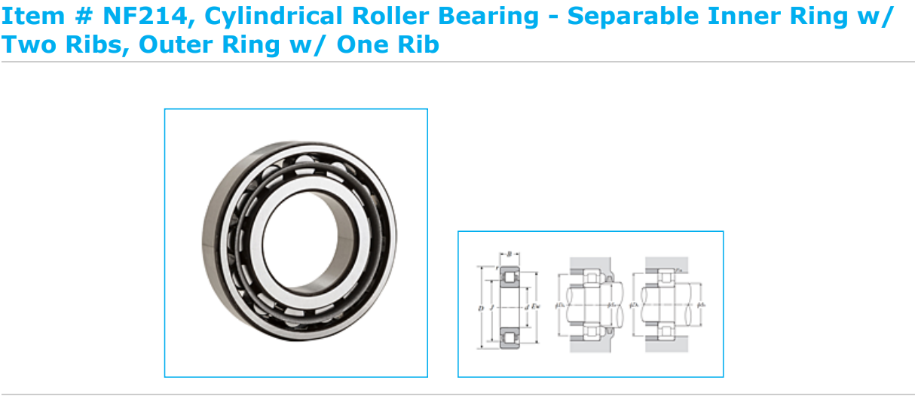 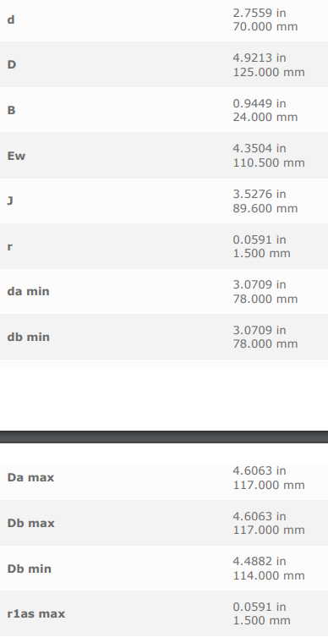 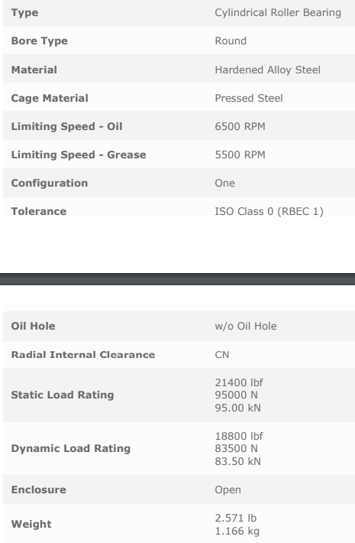

Selected Retaining Clips

